Abstract

In highly populated Countries just like India, in accidents, people lose their lives due to unavailability of proper medical facilities at the right time. This project senses any accident in the vehicle and intimates pre-programmed numbers like the owner of the vehicle, ambulance, police etc. if the accident is detected then the buzzer gives the alert then the driver has to press the button.

If the accident is normal, or driver has hit the wall in some situations like parking then driver will press the button then this indicates that the vehicle is safe, if the button is not pressed within the time limit then that means the people in the car are in trouble and it sends notification.

Vehicles are to be secured from both on road and off the road where as in case of on road one has to know about the accident(s) and in case of off the road vehicle thefts are to be controlled. When person wants to open the vehicle door. he has to press the button. After pressing the button. it notifies the owner by sending notification to mobile app and asks for authentication.

Now the door opens only after authentication. If unauthorized person tries to open the door then you can lock the car by pressing the button in the mobile App we can track our vehicle in the mobile app by using the GPS coordinates.

# Cloud Enabled Vehicle Theft & Accident Detection System

BY:

TRIO

K.Naga Ramya Sree

V.Mounika

S.Bhargavi

Project Working Process:

* A push button on vehicle is pressed.
* An OTP is generated as a message to the authorised car owner.
* If the same OTP is sent from the mobile application, the car door gets unlocked

(servo rotates).

* In case any accident occurs, an alert is sent using IBM cloud and buzzer goes high
* GPS position is also sent to related numbers as set priorly by the owner of the car as a safety measure.

**Arduino Uno:**

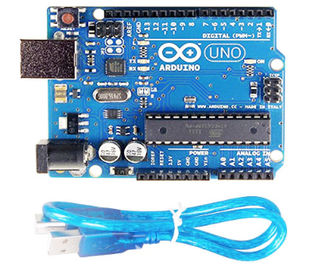

* Microcontroller: ATmega328P
* Operating Voltage: 5V
* Input Voltage (recommended): 7-12V
* Input Voltage (limit): 6-20V
* Digital I/O Pins: 14 (of which 6 provide PWM output)
* PWM Digital I/O Pins: 6
* Analog Input Pins: 6
* DC Current per I/O Pin: 20 mA
* DC current for 3.3V Pin: 50 mA
* Flash Memory: 32 KB (ATmega328P) of which 0.5 KB used by bootloader
* SRAM: 2 KB (ATmega328P)
* EEPROM: 1 KB (ATmega328P)
* Clock Speed: 16 MHz
* LED_BUILTIN: 13
* Length: 68.6 mm
* Width: 58.4 mm

Working Principle:

Arduino Uno is an open-source microcontroller board based on the microchip ATmega328P microcontroller and developed by Arduino.cc. The board is equipped with sets of Digital and Analog input/output pins that may be interfaced to various expansion boards and other circuits. Arduino can be Stand-alone or they can communicate with software on running on computer.

GPS Module:

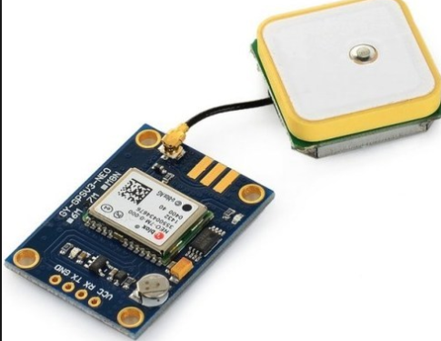

* Frequency 1575.42MHz-L1 C/A Code
* Cold Start Time 45 sec.
* I/O Port UART interface
* Warm Start Time 38 sec
* Protocol NMEA 0183
* Hot Start Time 10 sec.
* GPS Channel 16 Channels
* Reacquisition 100ms
* Operating Voltage 3.0 V ~ 6.0 V
* Update Rate 1Hz
* Operating Temperature -40°C ~ +85°C
* External Antenna Current Range 2mA ~ 25mA
* Power Consumption 27mA
* I/O Connector 1.27mm Pin Header
* Position Accuracy 3m CEP (50%), 7m EP (90%)
* Tracking Sensitivity -147dBm
* V Bat Voltage 1.0 V (MIN.), 2.0 V (MAX.)
* Dimensions 25mmX25mmX2.5mm (Excluding Connector)

Working Principle:

The working/operation of Global positioning system is based on the ‘trilateration’ mathematical principle. The position is determined from the distance measurements to satellites. 4 satellites are used to determine the position of the receiver on the earth. The target location is confirmed by   4 Satellite. And three satellites are used to trace the location place. A fourth satellite is used to confirm the target location of each of those space vehicles. Global positioning system consists of satellite, control station and monitor station and receiver. The GPS receiver takes the information from the satellite and uses the method of triangulation to determine a user’s exact position.

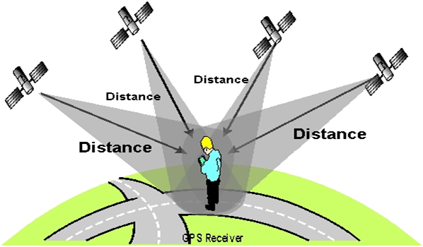

Servo Motor:

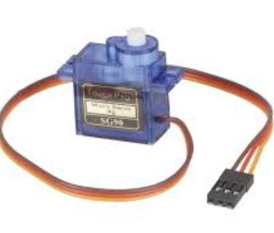

* Operating Voltage is +5V typically
* Torque: 2.5kg/cm
* Operating speed is 0.1s/60°
* Gear Type: Plastic
* Rotation: 0°-180°
* Weight of motor: 9gm
* Package includes gear horns and screws

Working Principle:

 Servo motors control position and speed very precisely. Now a potentiometer can sense the mechanical position of the shaft. Hence it couples with the motor shaft through gears. The current position of the shaft is converted into electrical signal by potentiometer, and is compared with the command input signal. We amplify this error signal and apply as the input to the motor hence the motor rotates. And when the shaft reaches to the require position, error signal become zero, and the command input is in form of electrical pulses. As the actual input to the motor is the difference between feedback signal (current position) and required signal, hence speed of the motor is proportional to the difference between the current position and required position. The amount of power require by the motor is proportional to the distance it needs to travel.2

Accelerometer:

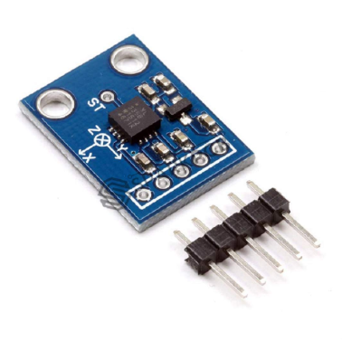

* 3V-6V DC Supply Voltage
* Onboard LDO Voltage regulator
* Can be interface with 3V3 or 5V Microcontroller.
* All necessary Components are populated.
* Ultra-Low Power: 40uA in measurement mode, 0.1uA in standby@ 2.5V
* Tap/Double Tap Detection
* Free-Fall Detection
* Analog output

Working Principle:

Which consists of a small mass which is etched into silicon surface and then integrated into a small circuit. When force is applied on this mass then it covers some displacement, so acceleration is produced in this mass according to newton second law of motion F= ma which is sensed by its sensor. Similarly, if we talk about Analog accelerometers then they work on two principles such as capacitive sensing and piezo electric sensing. Both have different advantages and disadvantages. Similarly, ADXL335 accelerometer is an Analog accelerometer therefore it works on the principle of capacitive sensing. In capacitive sensing accelerometer, when it is moved in any direction then its capacitance is changed. When this capacitance is changed then its Analog voltages are changed which is sensed by its interfacing controller.

NodeMCU (ESP8266 Arduino):

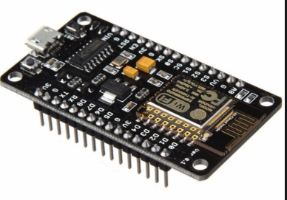

**Developer:** ESP8266 Opensource Community  
**Type:**  Single-board microcontroller  
**Operating system:** XTOS  
**CPU:** ESP8266  
**Memory:** 128kBytes  
**Storage:** 4MBytes  
**Power By:** USB  
**Power Voltage:** 3v ,5v (used with 3.3v Regulator which inbuilt on Board using Pin VIN)  
**Code:** Arduino CPP  
**IDE Used:** Arduino IDE  
**GPIO:** 10

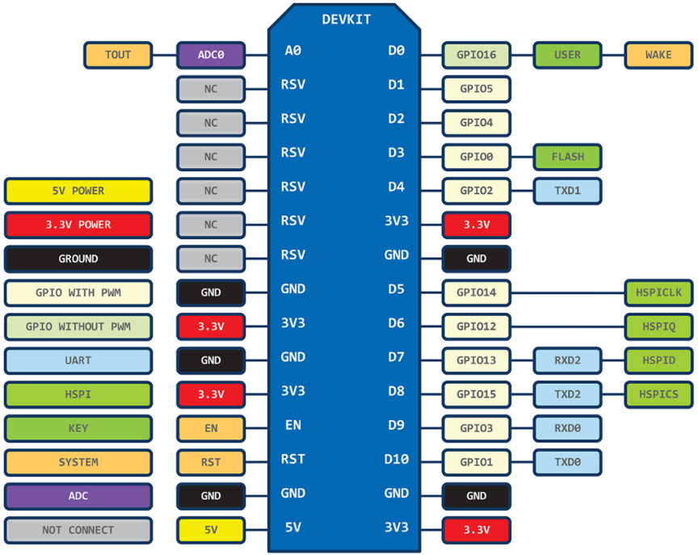

Working Principle:

The ESP8266 can be controlled from your local Wi-Fi network or from the internet (after port forwarding). The ESP-01 module has GPIO pins that can be programmed to turn an LED or a relay ON/OFF through the internet. The module can be programmed using an Arduino/USB-to-TTL converter through the serial pins (RX, TX).

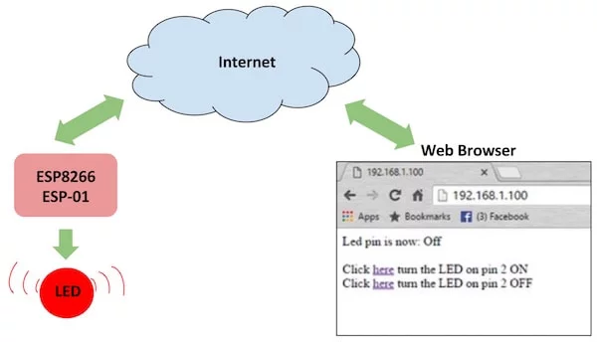

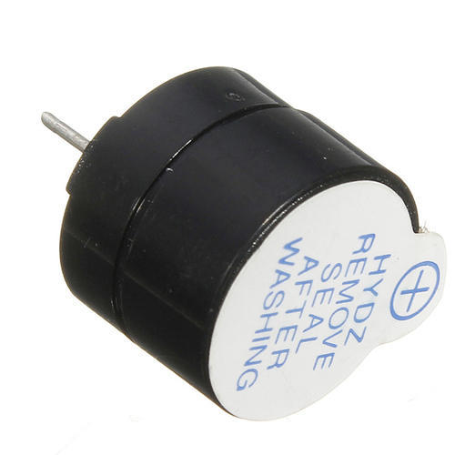Buzzer:

* Rated Voltage: 6V DC
* Operating Voltage: 4-8V DC
* Rated current: <30mA
* Sound Type: Continuous Beep
* Resonant Frequency: ~2300 Hz
* Small and neat sealed package
* Breadboard and Perf board friendly

Working Principle:

A **buzzer**is a small yet efficient component to add sound features to our project/system. It is very small and compact 2-pin structure hence can be easily used on [breadboard](https://components101.com/misc/breadboard-connections-uses-guide).

The simple buzzer which when powered will make a Continuous Beep.... sound, the other is called a readymade buzzer which will look bulkier than this and will produce a Beep. Beep. Beep. Sound due to the internal oscillating circuit present inside it. But the one shown here is most widely used because it can be customised with help of other circuits to fit easily in our application.

This buzzer can be used by simply powering it using a DC power supply ranging from 4V to 9V. A simple 9V battery can also be used, but it is recommended to use a regulated +5V or +6V DC supply. The buzzer is normally associated with a switching circuit to turn ON or turn OFF the buzzer at required time and require interval.

Push Button:

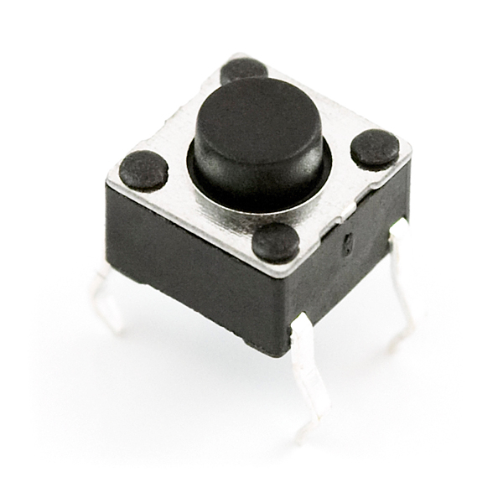

Working Principle:

A push button is a simple switch mechanism for controlling some aspect of a machine or a process. The surface of the button is usually flat or shaped to accommodate the human finger or hand, so as to be easily depressed or pushed. Buttons are most often biased switches.

Installation Process

Software to be installed in PC’s:

Step 1: Search [www.arduino.cc](http://www.arduino.cc) click on the download option and select the OS of your PC’s and the download process starts.



Step2: Installation process begins.

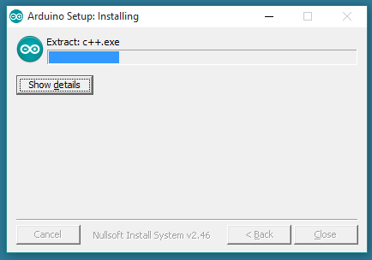

Step3: Accept the permissions and click next to continue the process.

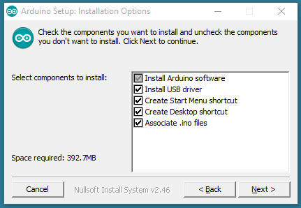

Step 4: click install button to get installed.

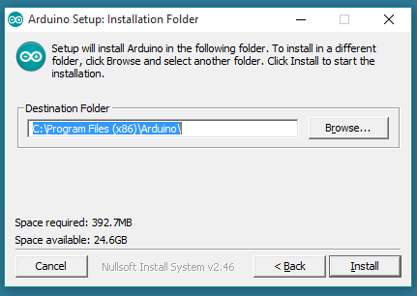

Step 5: Open the Arduino IDE and select the port and board icons.

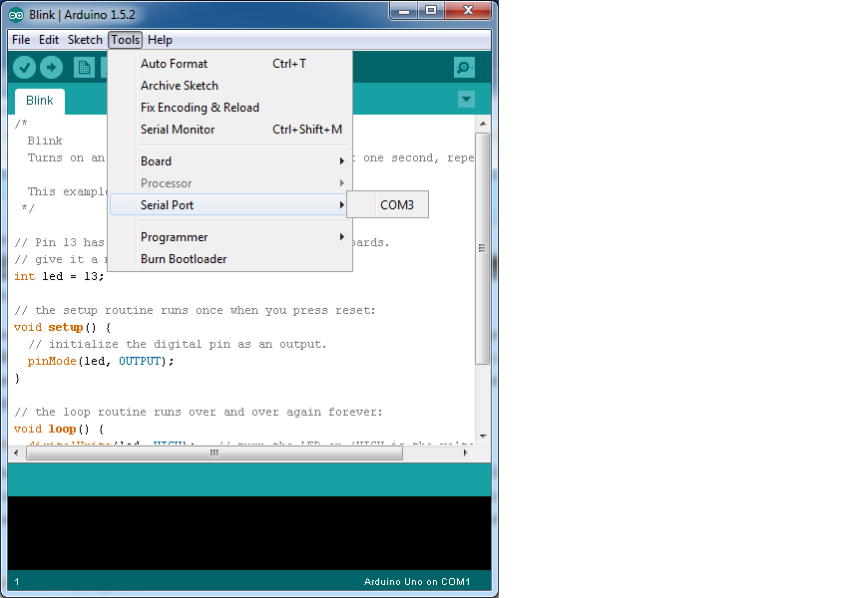

Library’s to be installed:

1.For vehicle Theft library’s

* ESP8266WiFi

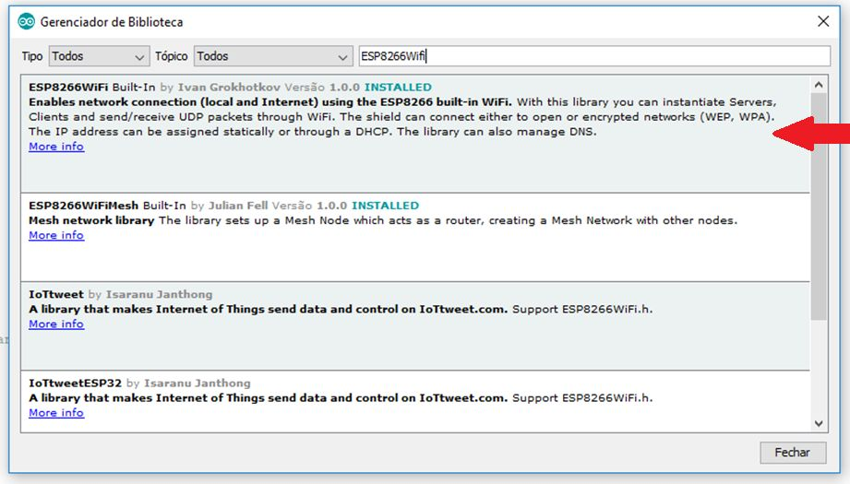

* WIFI Client Secure

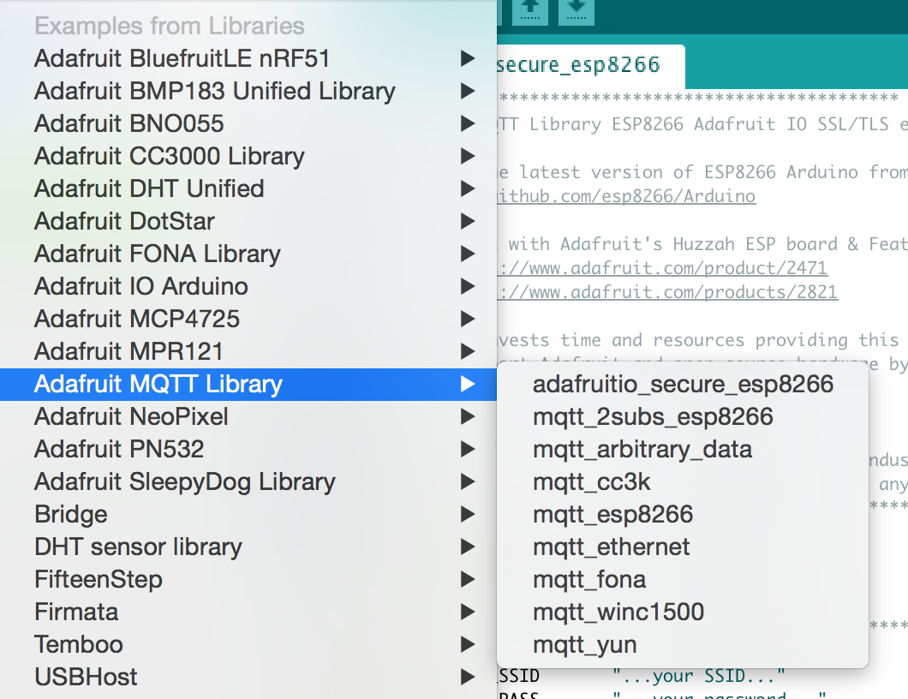

* SoftwareSerial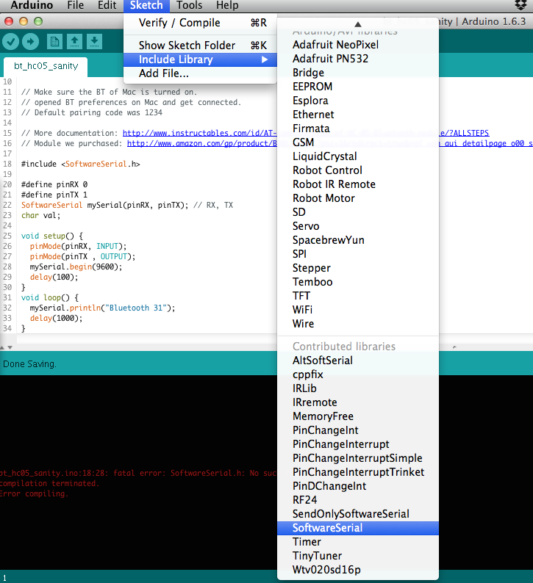
* Pub Sub Client

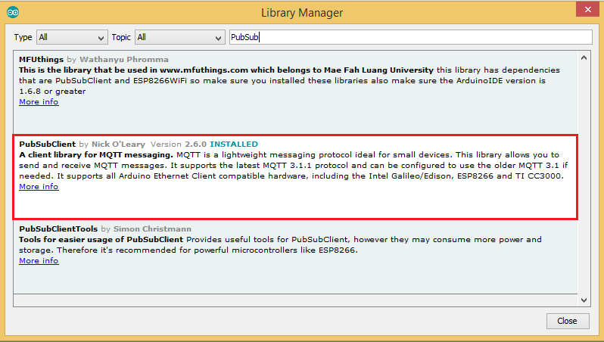

* Servo

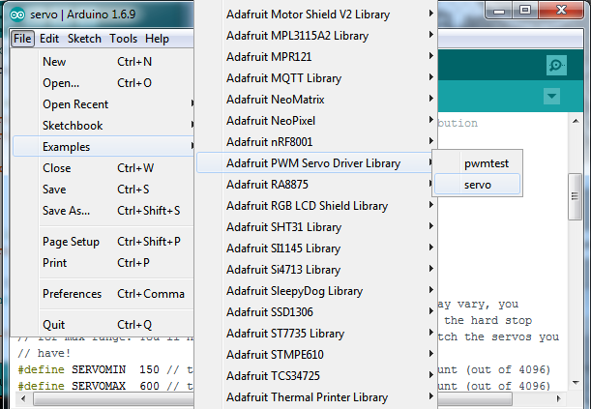

2.For Accident detection

* Tiny GPS++

